Part 1: Short Answer Questions (30 points)
1. Problem Definition (6 points)
- Hypothetical AI Problem: Predicting Student Dropout Rates in a University.
- Objectives:
  - To identify at-risk students early in the semester for timely intervention.
  - To understand the key factors (academic, demographic, engagement) that contribute to dropout risk.
  - To optimize the allocation of academic counseling and support resources.
- Stakeholders:
  - Students: The primary subjects whose academic journey is impacted.
  - University Administration: Responsible for student retention, resource allocation, and institutional success.
- Key Performance Indicator (KPI): Precision@K. The proportion of the top-K students flagged by the model who actually dropped out. This ensures that limited intervention resources are directed at the students most likely to be true positives.
2. Data Collection & Preprocessing (8 points)
- Data Sources:
  - Student Information System (SIS): Contains demographics, enrollment history, high school GPA, and declared major.
  - Learning Management System (LMS): Provides data on login frequency, assignment submission timeliness, quiz scores, and forum participation.
- Potential Bias: Socioeconomic Bias. Data from LMS (like access to a reliable computer and internet) might underrepresent challenges faced by students from lower-income backgrounds. If historical data is used to train the model, it might perpetuate past biases where certain demographic groups were less likely to receive support.
- Preprocessing Steps:
  - Handling Missing Data: For numeric features (e.g., quiz scores), impute missing values with the median. For categorical features (e.g., major), impute with a new category like "Unknown."
  - Normalization/Standardization: Scale numerical features (e.g., GPA, number of logins) to a common range (like 0-1) or standardize them to have a mean of 0 and standard deviation of 1. This is crucial for models sensitive to feature scales, like Neural Networks or SVMs.
  - Categorical Encoding: Convert categorical variables (e.g., department, gender) into numerical format using one-hot encoding to make them digestible for machine learning algorithms.
3. Model Development (8 points)
- Chosen Model: Gradient Boosting Machine (e.g., XGBoost, LightGBM).
- Justification: It provides high predictive accuracy, handles mixed data types (numeric and categorical) well, and offers good resistance to overfitting. It also provides feature importance, which adds a layer of interpretability for stakeholders.
- Data Splitting:
  - Training Set (70%): Used to train the model.
  - Validation Set (15%): Used for hyperparameter tuning and model selection during development.
  - Test Set (15%): Used only once, at the very end, to provide an unbiased evaluation of the final model's performance.
- Hyperparameters to Tune:
  - learning_rate: Controls how much each new tree corrects the mistakes of the previous ones. A lower rate is more robust to overfitting but requires more trees (and thus more computation).
  - max_depth: The maximum depth of each tree. Deeper trees can model more complex patterns but are highly prone to overfitting. Tuning this is a key trade-off between bias and variance.
4. Evaluation & Deployment (8 points)
- Evaluation Metrics:
  - Area Under the ROC Curve (AUC-ROC): Measures the model's ability to distinguish between the two classes (will-dropout vs. will-not-dropout) across all classification thresholds. It's a comprehensive metric for binary classification.
  - Recall (Sensitivity): The proportion of actual dropouts that the model correctly identifies. In this context, it's critical to catch as many at-risk students as possible, making high recall a priority.
- Concept Drift: This occurs when the statistical properties of the target variable or the input data change over time in the real world, making the model's predictions less accurate. For example, a new scholarship program or a global pandemic could drastically change student behavior and dropout patterns.
- Monitoring for Drift: I would monitor the model's performance metrics (e.g., precision, recall) on a held-back recent sample of data on a monthly basis. A significant drop would signal potential concept drift. I would also monitor the distribution of input features for shifts.
- Technical Challenge During Deployment: Scalability and Latency. When integrated into a live university system, the model must generate predictions for thousands of students quickly, especially at the beginning of a semester. Ensuring the inference API can handle this load with low latency is a key challenge.

Part 2: Case Study Application (40 points)
Scenario: Hospital Patient Readmission Risk Prediction
1. Problem Scope (5 points)
- Problem: To predict the probability that a patient will be readmitted to the hospital within 30 days of discharge.
- Objectives:
  - Enable proactive care interventions (e.g., follow-up calls, tailored discharge plans) for high-risk patients.
  - Improve patient outcomes and quality of life by preventing unnecessary hospitalizations.
  - Reduce healthcare costs for both the hospital and the patients.
- Stakeholders:
  - Patients: Their health is directly impacted.
  - Clinicians & Care Providers: Use the predictions to make decisions.
  - Hospital Administrators: Focused on cost, quality of care, and regulatory compliance.
  - Insurance Companies/Payers: Interested in cost reduction.
2. Data Strategy (10 points)
- Data Sources:
  - Electronic Health Records (EHRs): Primary source including diagnosis codes, medications, lab results, procedures, and length of stay.
  - Demographic & Socioeconomic Data: Age, gender, race, zip code (as a proxy for neighborhood factors), and insurance type.
- Ethical Concerns:
  - Patient Privacy & Data Security: EHR data is extremely sensitive. Unauthorized access or a data breach could have severe consequences for patients.
  - Algorithmic Bias: If the training data has historical biases (e.g., certain racial or socioeconomic groups receiving different levels of care), the model could learn and amplify these biases, leading to unfair predictions and unequal allocation of follow-up resources.
- Preprocessing & Feature Engineering Pipeline:
  - Data Cleaning: Handle missing lab values (impute with normal range median), remove duplicate records.
  - Feature Engineering:
    - Number_of_Previous_Admissions: Create a feature counting past admissions.
    - Comorbidity_Index: Create a composite score from the patient's list of diagnoses (e.g., using the Charlson Comorbidity Index).
    - Medication_Count: Total number of prescribed medications at discharge.
    - Length_of_Stay: The duration of the current admission.
  - Encoding: One-hot encode categorical variables (e.g., primary diagnosis code).
  - Normalization: Standardize numerical features like age, lab values, and the engineered features.
3. Model Development (10 points)
- Chosen Model: Logistic Regression.
- Justification: In healthcare, interpretability is often as important as accuracy. Clinicians need to understand why a patient is flagged as high-risk to trust and act upon the prediction. Logistic Regression provides easily explainable coefficients for each feature, showing its impact on the readmission risk. It's also less prone to overfitting with limited data and is computationally efficient.
- Hypothetical Confusion Matrix & Calculations:
  - Let's assume we have 1000 patients, and a classification threshold is set.
  - Confusion Matrix:
    - True Positive (TP) = 80 (Correctly predicted readmissions)
    - False Positive (FP) = 40 (Incorrectly predicted readmissions)
    - False Negative (FN) = 20 (Missed readmissions)
    - True Negative (TN) = 860 (Correctly predicted non-readmissions)
  - Precision = TP / (TP + FP) = 80 / (80 + 40) = 66.7%
    - Interpretation: When the model predicts a readmission, it is correct 66.7% of the time.
  - Recall = TP / (TP + FN) = 80 / (80 + 20) = 80.0%
    - Interpretation: The model identifies 80% of all actual readmissions.
4. Deployment & Optimization (15 points)
- Deployment Steps:
  - Model Packaging: Save the trained Logistic Regression model and its preprocessor as a versioned artifact (e.g., using pickle or joblib).
  - API Creation: Wrap the model in a REST API using a framework like Flask or FastAPI. The input is a patient's discharge data, and the output is a readmission risk score.
  - Integration: The hospital's EHR system can call this API automatically when a discharge summary is finalized.
  - Dashboard: Create a simple dashboard for care coordinators that lists discharged patients sorted by their predicted risk score.
- Ensuring Regulatory Compliance (HIPAA):
  - Data Anonymization/Pseudonymization: Use unique patient study IDs instead of direct identifiers in the model training pipeline.
  - Encryption: All data (in transit and at rest) must be encrypted.
  - Access Controls: Strict role-based access to the model, API, and underlying data.
  - Audit Trails: Log all access to patient data and model predictions.
- Optimization to Address Overfitting:
  - Method: L1 (Lasso) Regularization.
  - How it works: This technique adds a penalty to the loss function equal to the absolute value of the magnitude of coefficients. It can drive the coefficients of less important features to zero, effectively performing feature selection and producing a simpler, more robust model that is less likely to overfit to noise in the training data.

Part 3: Critical Thinking (20 points)
1. Ethics & Bias (10 points)
- Impact of Biased Data: If the training data is biased, the model's predictions will be biased. For example, if historical data shows that patients from a minority group were readmitted at a higher rate due to lack of access to post-discharge care (a systemic failure, not a biological one), the model may learn to associate race with high risk. This would be profoundly unethical. It could lead to:
  - Self-fulfilling prophecy: High-risk patients from this group might receive more resources, artificially inflating their readmission rate in the data further.
  - Resource Misallocation: Conversely, it could lead to under-provision of care for other groups if the model is systematically underestimating their risk.
  - Exacerbation of Health Disparities: The model could cement existing inequalities in the healthcare system.
- Mitigation Strategy: Pre-processing: Reweighting/Resampling. Analyze the training data for imbalances across sensitive attributes (like race, gender). Techniques like reweighting the loss function to give more importance to underrepresented groups, or using synthetic minority over-sampling technique (SMOTE) can help create a more balanced dataset before the model even begins training.
2. Trade-offs (10 points)
- Interpretability vs. Accuracy: In healthcare, a slightly less accurate model that is interpretable (like Logistic Regression or a small Decision Tree) is often more valuable than a "black box" model with higher accuracy (like a complex Neural Network). A clinician must be able to understand the reasoning behind a high-risk prediction to take appropriate, trusted action (e.g., "The model flagged this patient due to their age, number of comorbidities, and lack of a primary care physician follow-up"). Without interpretability, the model will not be adopted in practice.
- Impact of Limited Computational Resources: Limited resources would strongly favor simpler, more efficient models. Training a large neural network or a complex ensemble method would be infeasible. This constraint makes the choice of Logistic Regression or a shallow Decision Tree even more justified. It also impacts the frequency of model retraining—instead of continuous learning, the hospital might opt for periodic (e.g., quarterly) retraining to manage computational costs.

Part 4: Reflection & Workflow Diagram (10 points)
1. Reflection (5 points)
- Most Challenging Part: The most challenging part was navigating the trade-off between model performance and ethical implementation in the case study. It's technically straightforward to add more features to boost accuracy, but each feature carries a potential for bias. Deciding which features to exclude (e.g., using zip code as a direct feature might proxy for race) required deep critical thinking beyond pure coding. Ensuring the model is fair and compliant with regulations like HIPAA adds layers of complexity that are not present in academic machine learning exercises.
- Improvement with More Time/Resources: With more time and resources, I would:
  - Implement a robust MLOps pipeline for continuous monitoring of model performance and data drift, triggering automatic retraining when performance degrades.
  - Conduct a thorough fairness audit using tools like AIF360 to quantitatively measure bias across different patient subgroups and iterate on the model to minimize disparities.
  - Develop a more sophisticated feature engineering pipeline, potentially incorporating time-series data from patient vitals or natural language processing (NLP) on doctor's notes.
2. Workflow Diagram (5 points)
The following flowchart outlines the iterative AI Development Workflow:
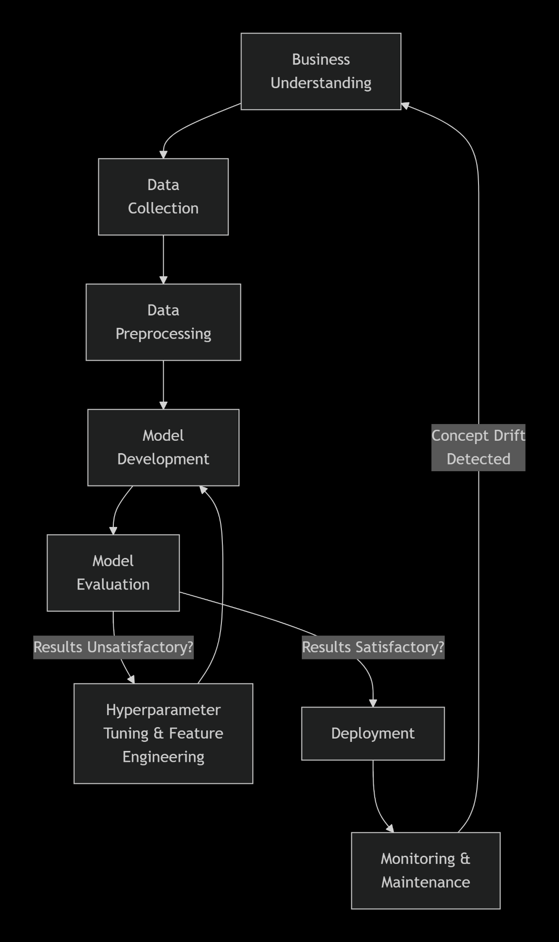
Stages:
- Business Understanding: Define the problem, objectives, and constraints (Part 1.1 & Part 2.1).
- Data Collection: Identify and gather data from relevant sources (Part 1.2 & Part 2.2).
- Data Preprocessing: Clean, engineer features, and prepare data for modeling (Part 1.2 & Part 2.2).
- Model Development: Select, justify, and train machine learning models (Part 1.3 & Part 2.3).
- Model Evaluation: Critically assess model performance using relevant metrics (Part 1.4 & Part 2.3).
- Deployment: Integrate the model into the real-world system (Part 1.4 & Part 2.4).
- Monitoring & Maintenance: Continuously monitor for performance decay and concept drift, restarting the cycle (Part 1.4).

